

Title:
“Multipurpose SOS & Live Tracking System”

Introduction:
Personal safety for children, the elderly, and valuable assets is a growing concern. Standard trackers often rely solely on the internet or lack user interfaces. Our project builds a standalone, handheld IoT device designed for personal safety. It utilizes a hybrid communication model, seamlessly switching between GPS/GPRS for outdoor tracking and LBS (Cell Tower)/SMS for indoor emergencies where satellite signals fail. It features an onboard OLED display for real-time status feedback.

Hardware Components:
The system is built on the following core components:
- Microcontroller: ESP32 Dev Module (Dual-core processor handling logic, UI, and connectivity).
- Connectivity: SIM800L GSM Module (Handles 2G Internet, SMS, and Voice Calls).
- Positioning: NEO-6M GPS Module (Acquires satellite coordinates).
- Interface:
  - SSD1306 OLED Display: Shows battery status, signal strength, GPS lock, and menu system.
  - Navigation Buttons: 3x Tactile Buttons (Up, Down, Select) for menu control.
- Audio: Electret Microphone (For ambient sound monitoring).
- Power System: 18650 Li-Ion Battery managed by a Single-Chip Power Bank Module (IP5306/SW6106) for charging and 5V boost.

System Architecture & Circuit:
The ESP32 acts as the central brain. It parses NMEA data from the GPS via UART2 and communicates with the SIM800L via UART1. The system uses a dedicated "Power Hub" architecture where high-current components (GSM) draw directly from the battery, while logic components (ESP32, GPS, OLED) run on regulated voltage.
- Architecture Diagram:
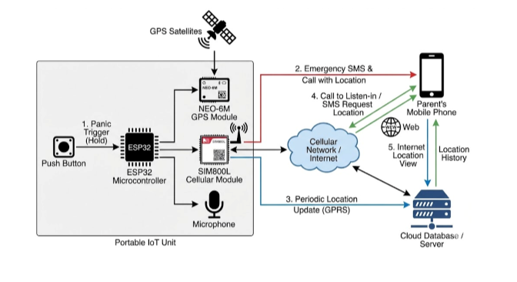
Circuit Diagram:
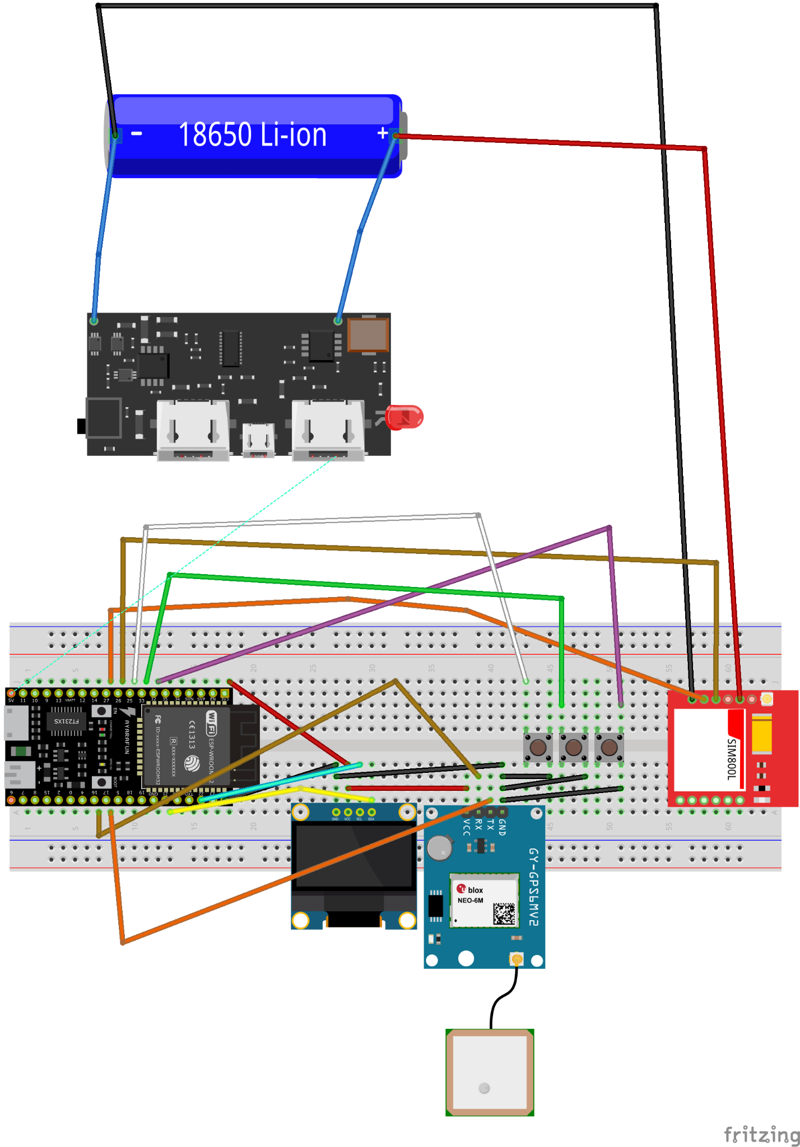
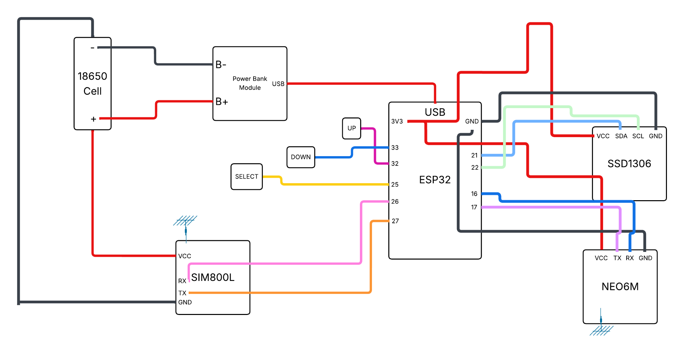

Key Functionalities:
The device operates with a robust state-machine logic:
- SOS Panic Mode:
  - Triggered by holding the Select Button for 5 seconds or selecting "Panic" from the menu.
  - Action: Immediately sends an emergency SMS with a Google Maps link to the guardian. It then automatically disconnects GPRS and initiates a Voice Call to the guardian, allowing them to hear the surroundings immediately.
- Hybrid Location Tracking (GPS + LBS):
  - Outdoors: Uses precise GPS coordinates (accuracy ~5m).
  - Indoors: Automatically falls back to LBS (Location Based Services) using Cell Tower triangulation when GPS satellites are blocked, ensuring location is never lost.
- Live Mode vs. Standby:
  - Standby: Uploads location every 5 minutes to save battery.
  - Live Mode: A menu option that increases upload frequency to every 10 seconds for real-time vehicle/person tracking.
- Remote "Spy" Monitoring:
  - Guardians can trigger a "Spy Call" remotely via the Web Dashboard or by sending an SMS command.
  - The device silently dials the guardian's phone, activating the onboard microphone for remote listening.
- Secure Admin Console:
  - A password-protected dashboard allows guardians to view live location, historical paths, battery status, and change the registered "Guardian Number" remotely.

Software Implementation:
- Firmware: Developed in C++ using PlatformIO (VS Code). Implements a non-blocking UI loop to keep the OLED responsive while handling network tasks.
- Communication Bridge (The "Middleware"):
  - Uplink (Data): Uses ThingSpeak ThingHTTP. The ESP32 sends lightweight HTTP GET requests, which ThingSpeak relays as secure HTTPS POST requests to the backend. This bypasses the SIM800L's SSL limitations.
  - Downlink (Commands): Uses ThingSpeak TalkBack. The ESP32 polls this queue to receive commands like "Force Update" or "Spy Call" from the dashboard.
- Backend & Database:
  - Next.js 14 (App Router): Hosted on Vercel. Handles API routes for data processing and serves the frontend.
  - MongoDB Atlas: Stores location history, command logs, and system settings (including the admin password).
- Frontend:
  - Built with React, Tailwind CSS, and ShadCN UI.
  - Features a dark-mode interactive map (Leaflet) and a responsive mobile-first design.

